**THREE CLOUD PROVIDERs _____________**

1. **AZURE**
2. **AWS**
3. **GCP**

**Services Name –**

**Scalable virtual machine**

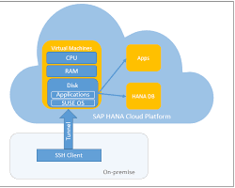

**Storage**

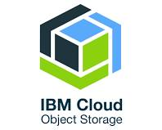

**DATABASE**

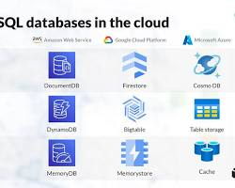

**Lamada -email or WhatsApp service (serverless computing)**

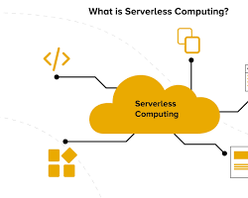

**VPC networks**

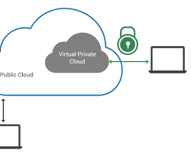

**CDN Networks**

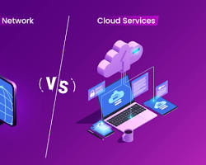

**Managing Kubernetes**

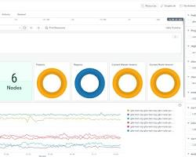

**Messaging Services**

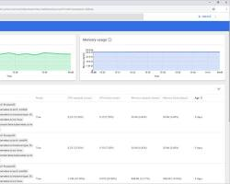

**Identity Management Services**

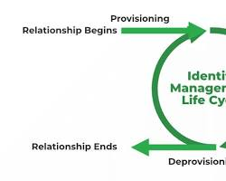

**Monitoring Services**

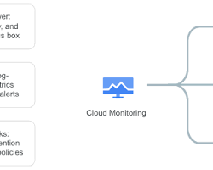

|  |  |  |
| --- | --- | --- |
| **Cloud Provider** | **Service Name** | **Explanation and Examples** |
| **AWS** | **Amazon Elastic Compute Cloud (EC2)** | **Scalable virtual servers for running applications. Example: Deploy a web application on a Linux EC2 instance.** |
| **Azure** | **Azure Virtual Machines** | **Similar to EC2, offering on-demand, scalable virtual machines. Example: Run a Windows server for database hosting.** |
| **GCP** | **Google Compute Engine (GCE)** | **Provides virtual machines with customizable configurations. Example: Host a gaming server on a high-performance GCE instance.** |
| **Cloud Provider** | **Service Name** | **Explanation and Examples** |
| **AWS** | **Simple Storage Service (S3)** | **Object storage for any type of data. Example: Store images, videos, and static website content.** |
| **Azure** | **Azure Blob Storage** | **Storage for unstructured data, similar to S3. Example: Retain backup files or host media content.** |
| **GCP** | **Cloud Storage** | **Object storage with high availability and scalability. Example: Archive large datasets for analytics.** |
| **Cloud Provider** | **Service Name** | **Explanation and Examples** |
| **AWS** | **Relational Database Service (RDS)** | **Managed relational database service (MySQL, PostgreSQL, Oracle, SQL Server). Example: Host a production database for an e-commerce application.** |
| **Azure** | **Azure SQL Database** | **Managed SQL database service for various workloads. Example: Create a database for a CRM system.** |
| **GCP** | **Cloud SQL** | **Managed MySQL, PostgreSQL, and SQL Server databases. Example: Run a database for a social media platform.** |
| **Cloud Provider** | **Service Name** | **Explanation and Examples** |
| **AWS** | **Lambda** | **Serverless compute service for running code without managing servers. Example: Trigger a Lambda function to process image uploads.** |
| **Azure** | **Azure Functions** | **Serverless platform for event-driven functions. Example: Create a function to send email notifications.** |
| **GCP** | **Cloud Functions** | **Serverless environment for building event-driven applications. Example: Develop a function to resize uploaded images.** |
| **Cloud Provider** | **Service Name** | **Explanation and Examples** |
| **AWS** | **Elastic Container Service (ECS)** | **Orchestrates container workloads on a cluster of EC2 instances. Example: Deploy a microservices architecture using Docker containers.** |
| **Azure** | **Azure Kubernetes Service (AKS)** | **Managed Kubernetes service for deploying and managing containerized applications. Example: Run a containerized web application with load balancing.** |
| **GCP** | **Google Kubernetes Engine (GKE)** | **Managed Kubernetes service for scaling and managing containerized applications. Example: Deploy a machine learning model in a container.** |
| **Cloud Provider** | **Service Name** | **Explanation and Examples** |
| **AWS** | **Simple Queue Service (SQS)** | **Fully managed message queuing service. Example: Decouple microservices by integrating SQS queues.** |
| **Azure** | **Azure Service Bus** | **Cloud messaging service with message queues and publish-subscribe topics. Example: Implement asynchronous communication between services.** |
| **GCP** | **Pub/Sub** | **Scalable messaging service for asynchronous communication. Example: Process real-time data streams for analytics.** |
| **Cloud Provider** | **Service Name** | **Explanation and Examples** |
| **AWS** | **Virtual Private Cloud (VPC)** | **Isolated virtual network for resources within AWS. Example: Create a secure network for production workloads.** |
| **Azure** | **Virtual Network** | **Similar to VPC, providing a private network within Azure. Example: Segment different environments for development, testing, and production.** |
| **GCP** | **Virtual Private Cloud (VPC)** | **Isolated network for resources within GCP. Example: Configure firewall rules to control traffic within the VPC.** |
| **Cloud Provider** | **Service Name** | **Explanation and Examples** |
| **AWS** | **CloudFront** | **Content delivery network (CDN) for distributing content globally. Example: Cache static assets like images and videos to improve website performance.** |
| **Azure** | **Azure Content Delivery Network (CDN)** | **Global CDN for delivering content with low latency. Example: Distribute streaming videos to users worldwide.** |
| **GCP** | **Cloud CDN** | **CDN built on Google's global infrastructure. Example: Accelerate delivery of web applications and APIs.** |